1: Find out the top 10 destination people travel the most: Based on the given data, we can find the most popular destination that people travel frequently. There are many destinations out of which we will find only first 20, based on trips booked for particular destinations.

Driver:

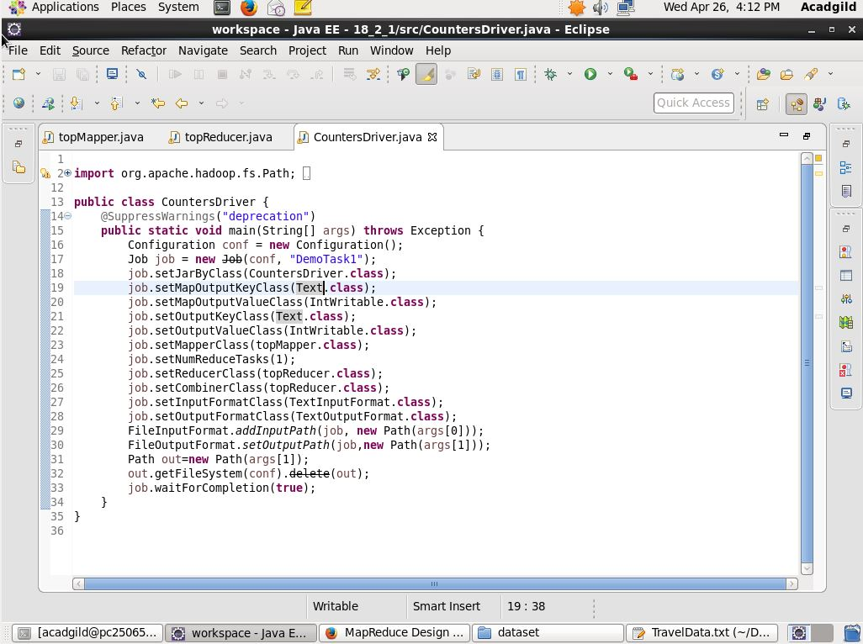

Mapper: here we are storing the from and to location and the total number of passengers by adding all the number of adults, senior citizen, infants, children, etc.

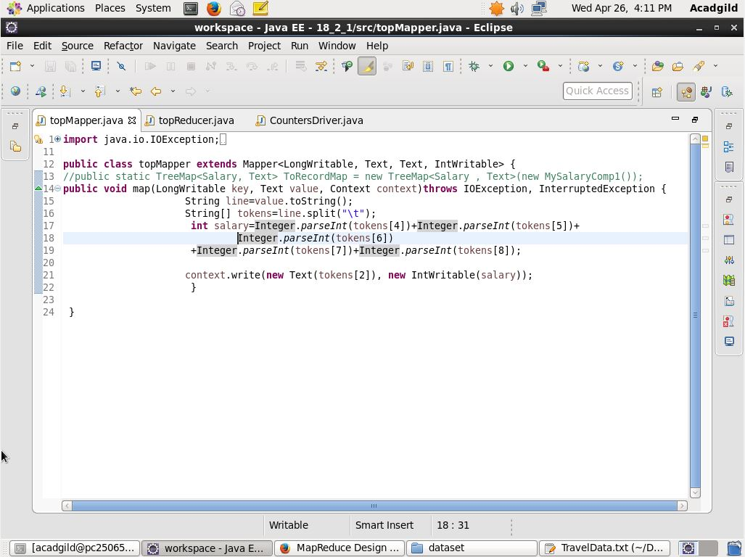

Reducer: here the total number of passengers are added and stored in the treemap. Cleanup method is used to get the first 10 travel destinations on the number of tickets booked by the passengers.

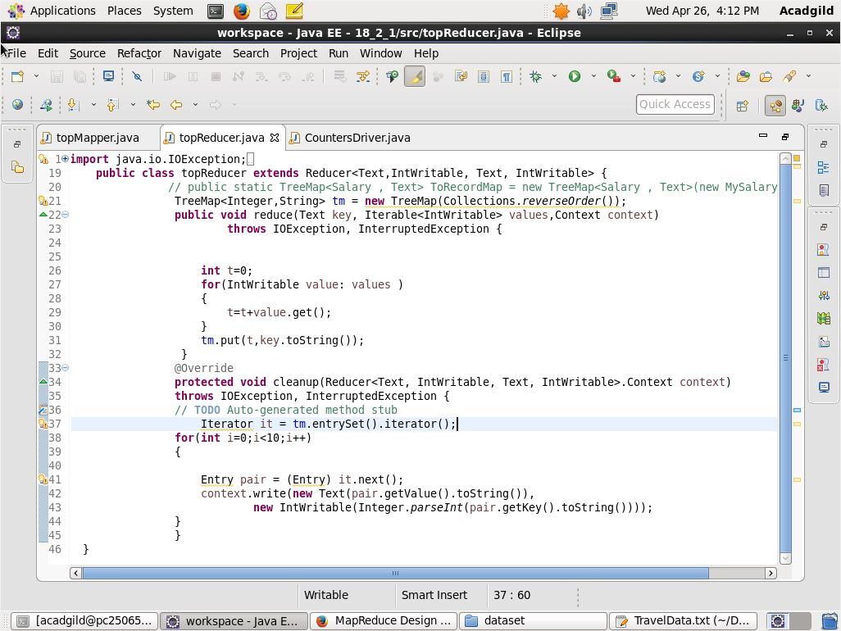

Answer:

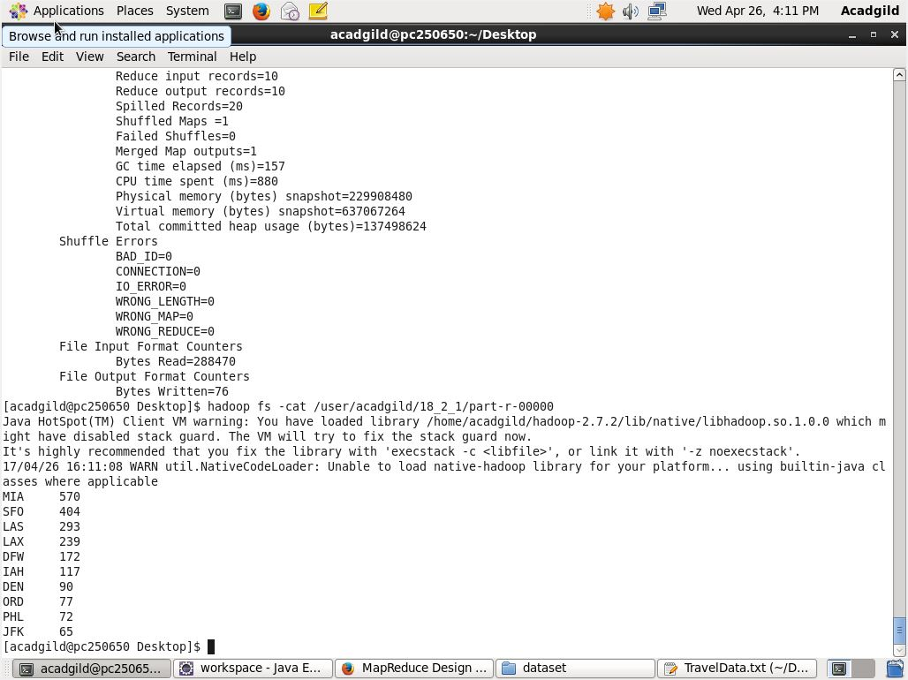

2: Find out the top 10 cities that generate high airline revenues for travel, so that the site can concentrate on offering discount on booking, to those cities to attract more bookings.

Driver:



Mapper:

Here we are taking key as the pair of from and to location and also as the condition is specified the condition for the air is also checked. And in the value we are passing the booking price.

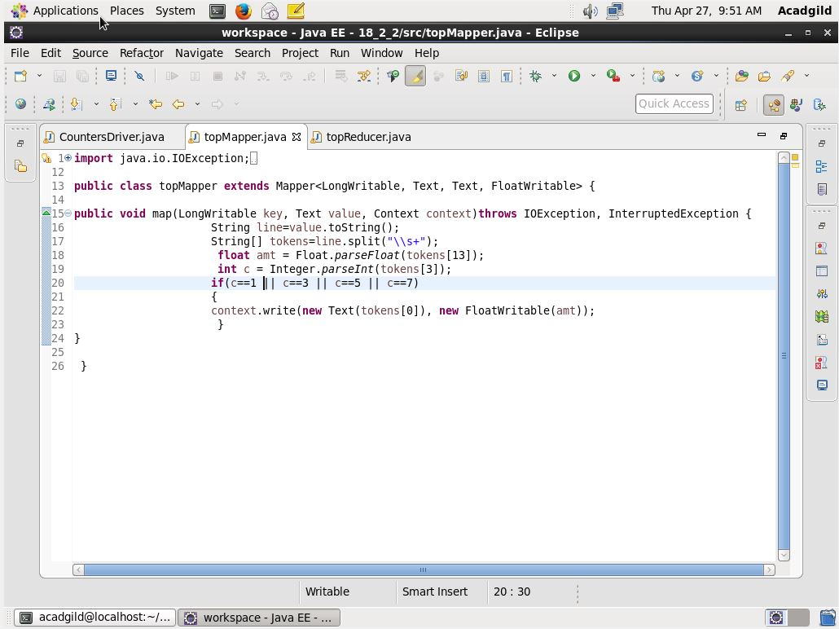

Driver:

Here we are adding all the booking prices for the pair and the top ten locations are written. For this to be achieved we have first added all the key value pair in TreeMap and then the cleanup method is used to get the first top 10 values.

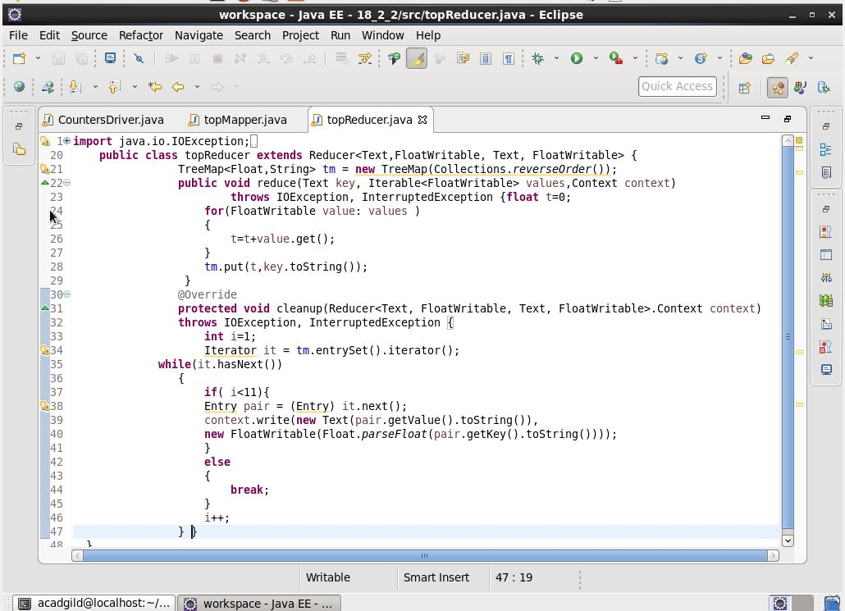

Answer:

